

National University of Sciences and Technology Islamabad

**School of Mechanical and Manufacturing**

**Engineering**

**Fundamentals of Programming lab**

**Mechanical Engineering**

**Section B**

**Assignment#3**

**Submitted by:**

Muhammad Shahzeb Khan

**Registration#:**

479677

**Submitted to:**

Sir Saqib

**Due Date:**

October 17,2023

**Question1:**

**Write code in C++ to show population in all provinces of Pakistan using switch case.**

#include<iostream>

#include<string>

using namespace std;

int main (){ int province;// declaring variables

cout<<”press ‘1’ for Punjab, ‘2’ for Sindh, ‘3’ for kpk, ‘4’ for Balochistan”<<endl;

cout<<”enter province”<<endl;

cin>>province;// demanding input

switch(province)

{ //applying cases

case 1:

cout<<”population of Punjab is 112.7M”<<endl;

break;

case 2:

cout<<”population of Sindh is 55.69M”<<endl;

break;

case 3:

cout<<”population of kpk is 40.8M”<<endl;

break;

case 4:

cout<<”population of Balochistan is 21.7M”<<endl;

break;

default:// applying default condition

cout<<”missing input”<<endl;

}}

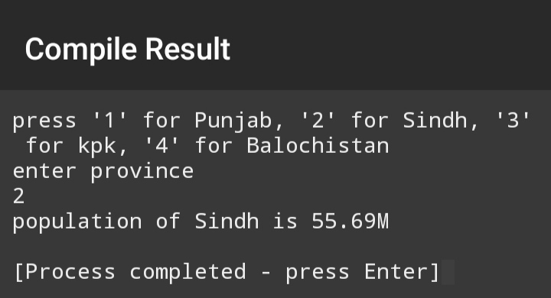

**Question 2:**

**Write a C++ program to check whether an alphabet is a vowel or consonant using a switch case**

#include<iostream>

#include<string>

using namespace std;

int main (){ char alphabet;// declaring variables

cout<<”enter alphabet”<<endl;

cin>>alphabet;

switch(alphabet)//applying switch statement

{

case ‘a’ :case ‘e’:case ‘o’: case ‘i’: case ‘u’://applied first case

cout<<”alphabet is vowel”<<endl;

break;

default://applied default case

cout<<”alphabet is consonant”<<endl;}

Question 3: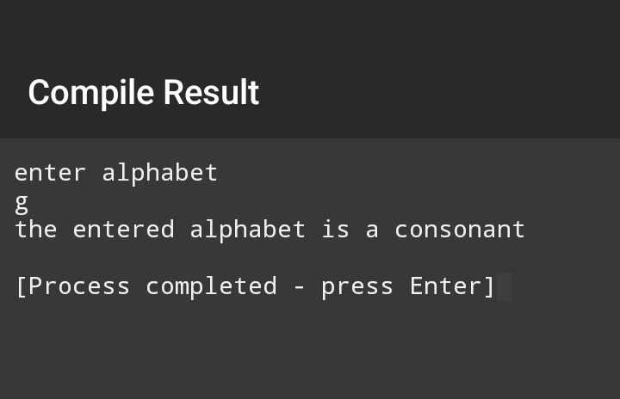**Write code in C++ to show the input number is zero, negative or a positive number using switch case.**

#include<iostream>

using namespace std;

int main(){ int number;// decalaring variables

cout<<”enter number”<<endl;

cin>>number;

switch(number)// gave switch statement

case 0:// applied first case

cout<<”number you entered is zero”<<endl;

if(number>=0){cout<<”number you entered is positive number”<<endl;}

else{cout<<”number you entered is a negative number”<<endl;}

}

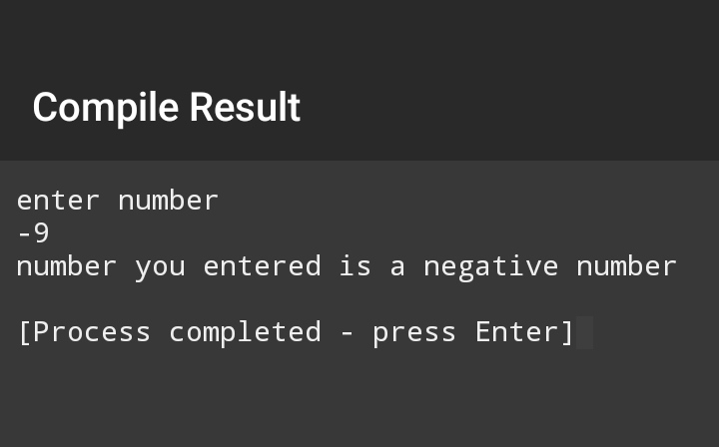**Question 4:**

**Write code in C++ to find out whether person is adult, teenager or child using nested if else condition**

#include<iostream>

#include<string>

using namespace std;

int main ()

{ int age;// declaring variables

cout<<”enter age”<<endl;

cin>>age;

if(age<=40){if(age>=18&&age<=40) //applied if condition

{cout<<”person is adult”<<endl;}

else{if(age>=13&&age<18){

cout<<”person is teenager”<<endl;}

else{cout<<”person is child”<<endl;}}}//applied nested else if condition

else{cout<<”person is older”<<endl;}

}

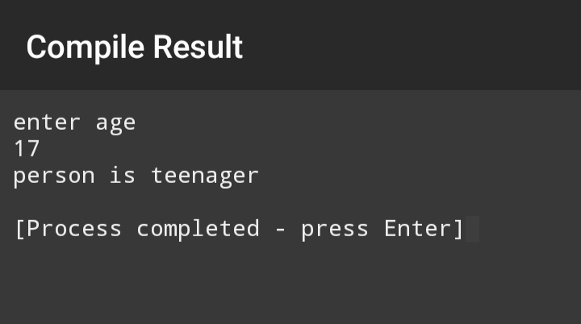

**Question 5:**

**Write code in C++ to find greatest number out of three numbers using nested if else condition**

#include<iostream>

using namespace std;

int main() { int num1,num2,num3;// declaring variables

cout<<”enter num1”<<endl;

cin>>num1;//demanding input

cout<<”enter num2”<<endl;

cin>>num2;

cout<<”enter num3”<<endl;

cin>>num3;

if(num1>num2){ if(num1>num3){cout<<”num1 is greatest number”<<endl;

}//checking if num1 is greatest

else{cout<<”num3 is greatest number”<<endl;

}

}

else if(num2>num1){ if(num2>num3){ cout<<”num2 is greatest number”<<endl;

}//checking if num2 is greatest number of all

else{cout<<”num3 is greatest number”<<endl;

}}

else{if(num3>num2&&num3>1&&num1>num2){ cout<<”num3 is greatest number”<<endl;

}//checking if num3 is greatest number out of all

else{cout<<”num1 is greatest number”<<endl;

}}}

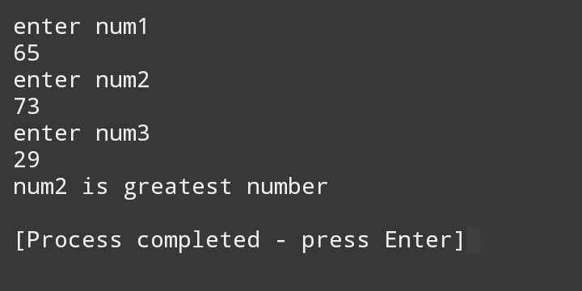

**Question 6:**

**Write code in C++ to determine whether alphabet is vowel or consonant using nested if else condition**

#include<iostream>

using namespace std;

int main() { char alphabet;//declaring variables

cout<<”enter alphabet”<<endl;

cin>>alphabet;

if(alphabet==’a’){cout<<”the alphabet is vowel”<<endl;}// applied if condition

else {if(alphabet==’e’){cout<<”the alphabet is vowel”<<endl;}// applied nested if else condition

else {if(alphabet==’I’){cout<<”the alphabet is vowel”<<endl;}

else {if(alphabet==’o’){cout<<”the alphabet is vowel”<<endl;}

else {if(alphabet==’u’){cout<<”the alphabet is vowel”<<endl;}

else{cout<<”the entered alphabet is a consonant”<<endl;}

}}}}}

